Container Registry

Like we have Docker hub where we put all our images , now we will put them in the container Registry in Azure

We can work in <https://shell.azure.com/>

Here some of the modules are already installed

But in Windows and ubuntu machines, we need to install docker

So, first install docker on VBM’s

Then to check

docker –version

Why Docker?

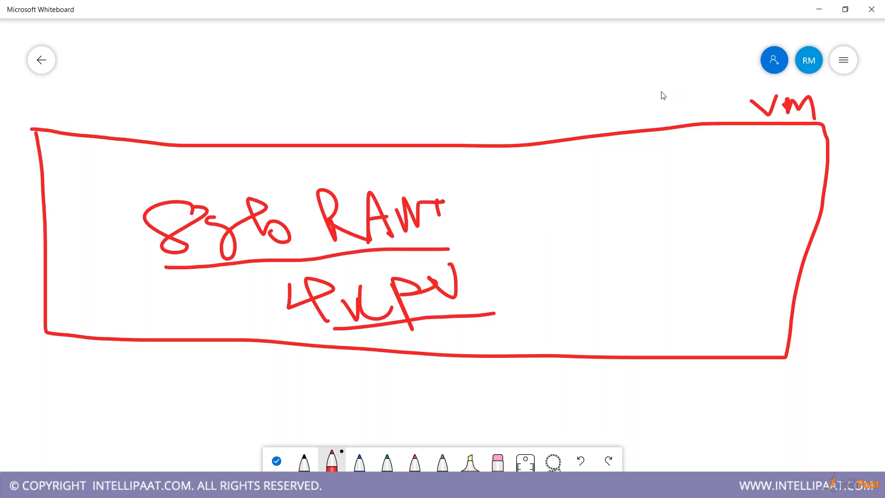

This one VM is dedicated to one application. We want to utilize it max. Or we use Containerization

It helps to utilize the resources efficiently,

Also if we don’t use it , developer, tester, other guys will be requiring same configuration or different in different VM’s. SO what we can do we can create some small containers in one VM, and can allot these containers to different people

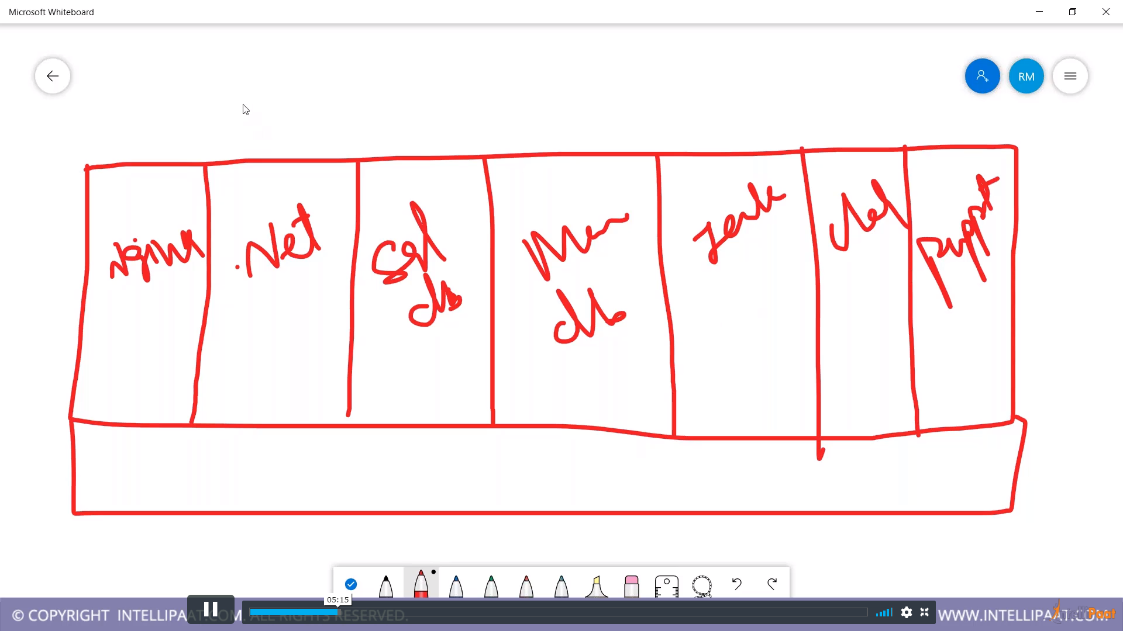

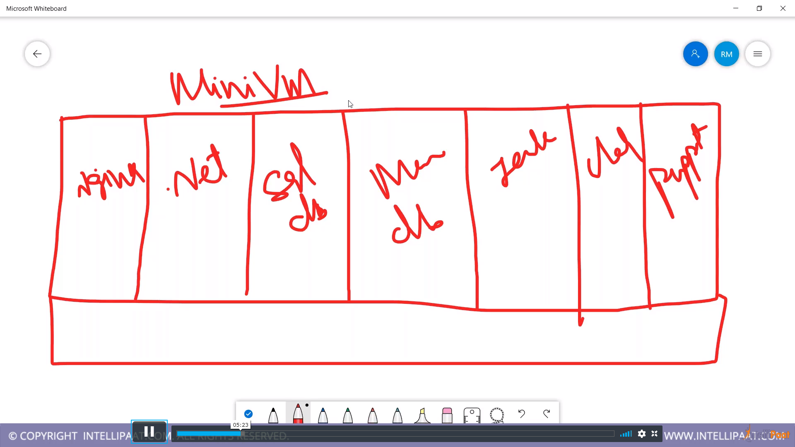

Create a Ubuntu Machine

Install docker

Sudo apt install docker.io

Now in azure portal, create container registry

It’s a service offered by Microsoft which will store the images

We know that in order to create VM, we all need OS image , similarly to create container , we need images

To store these images , we need some kind of repository. It could be docker hub or Azure registry

(ACR)

Where we can store container images

Go to VM now

Docker –v

Docker –help

Now create s simple container

Docker container run –d --name test-container –p 81:80 nginx

It will create a Mini VM which contains nginx

Now we can see this container

Docker container ls

ON your VM, allow all ports

Copy the public IP

IP:81

Now container is running

Now upload this container to ACR

This image is coming from docker.hub

We can check

Docker image ls

Go to portal

Container Registry

Copy the server name

In VM

Docker login servername

To upload the images to container,

We need to first build the image

Check in google : Azure container registry

We need to tag it

Docker tag nginx path/samples/nginx

Now run

Docker image ls

U shud see two images

Docker push path/samples/nginx

Check the container

Docker container ls

Docker container rm –f test-container

Docker image rm give the image id1 id2

Now there is no image here

Now we will pull the image from ACR

Docker pull path/samples/nginx

Docker image ls

Now create a container out of this image

Docker container run –d –name test2 -p 8089:80 copy the image name

It will create container for us

Docker container ls

Again go to VM

Ip:8089

CONTAINER INSTANCE

